* Hotel Booking

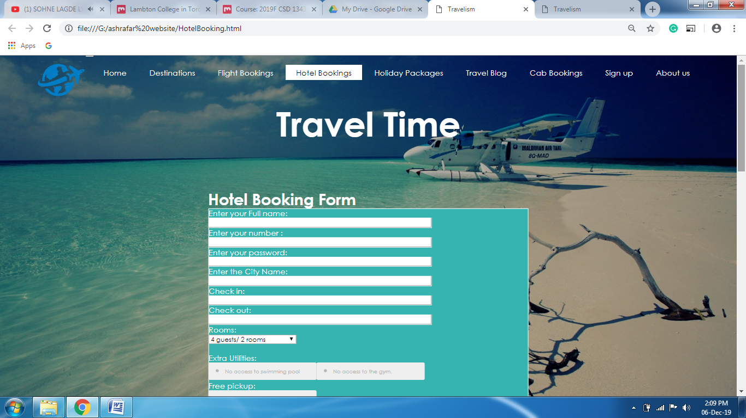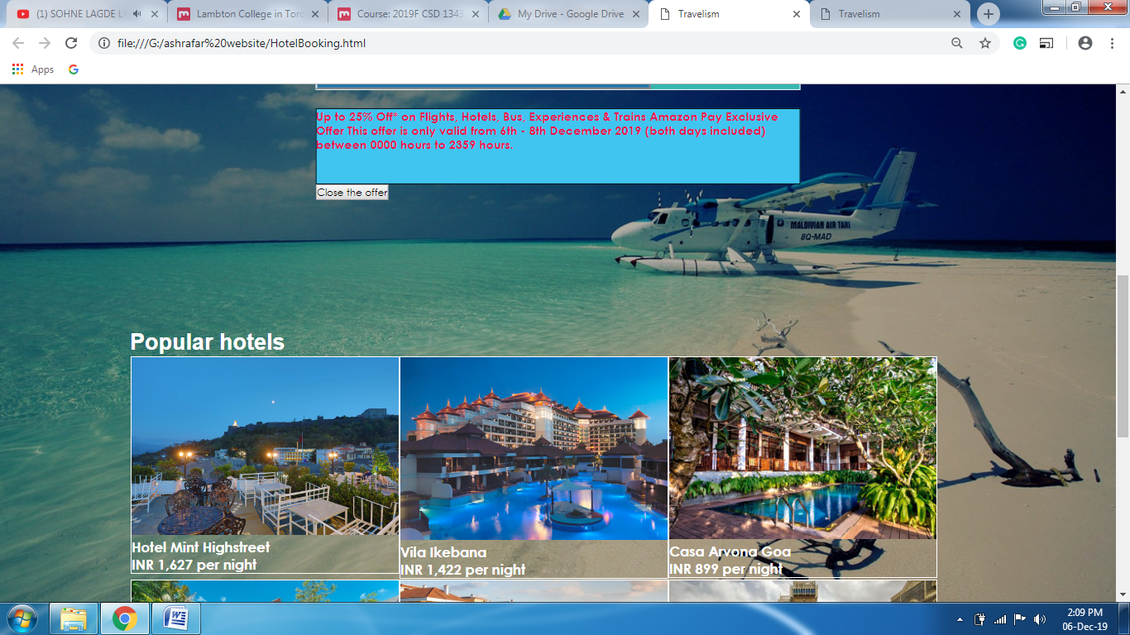

In this page , the customer can book a room in the hotel. There is a hotel booking form that contains the info that the customer needs to fill. Validation plugin known as validetta has been used in this form. Moreover, labelauty plugin has been used in the utilities section of the form. There is a offer that has been shown under the form with a button , when clicked will close the offer with fold effect.

* Travel Blog

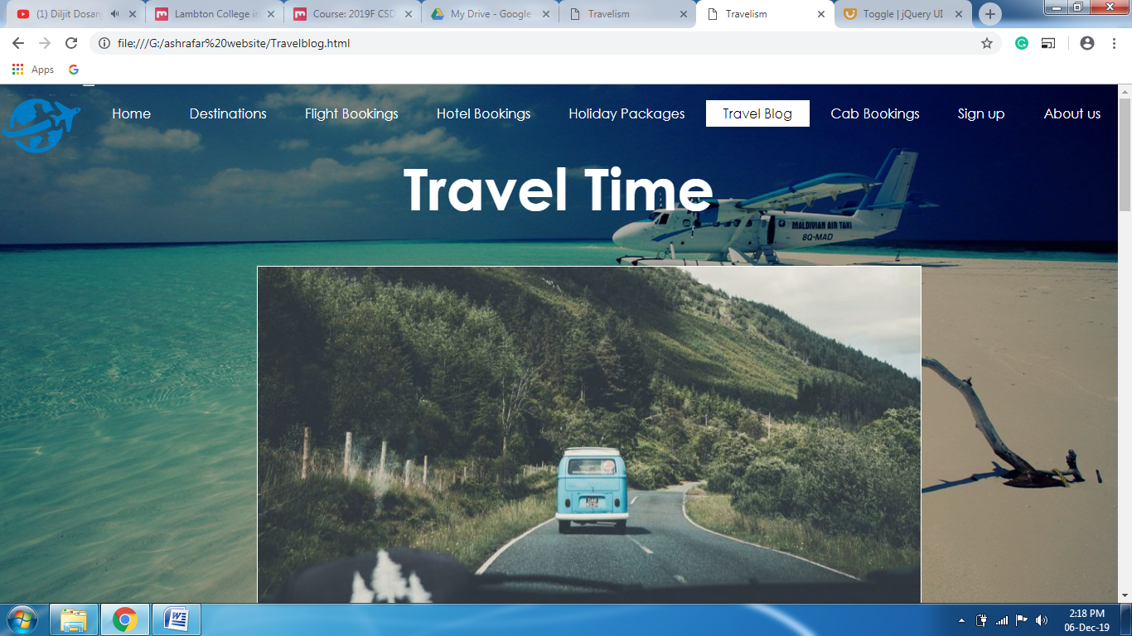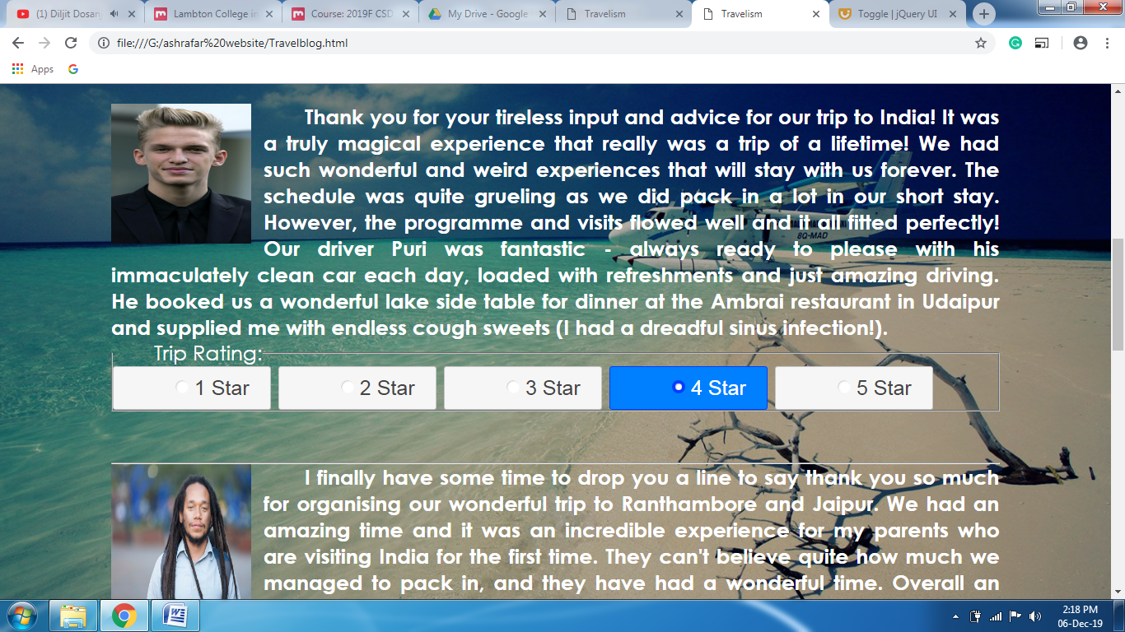

This page contains the reviews by the travel bloggers . The cycle 2 plugin has been used for the image slideshow. For the review stars , checkboxradio widget has been used .Moreover , I have used the color animation in the goodbye message.

* Cab Bookings

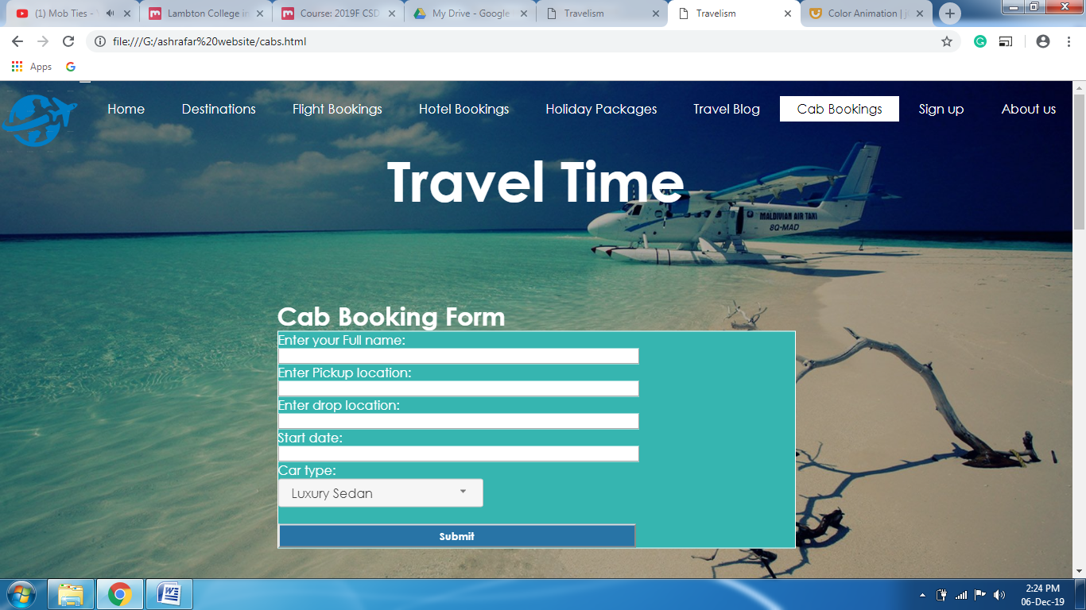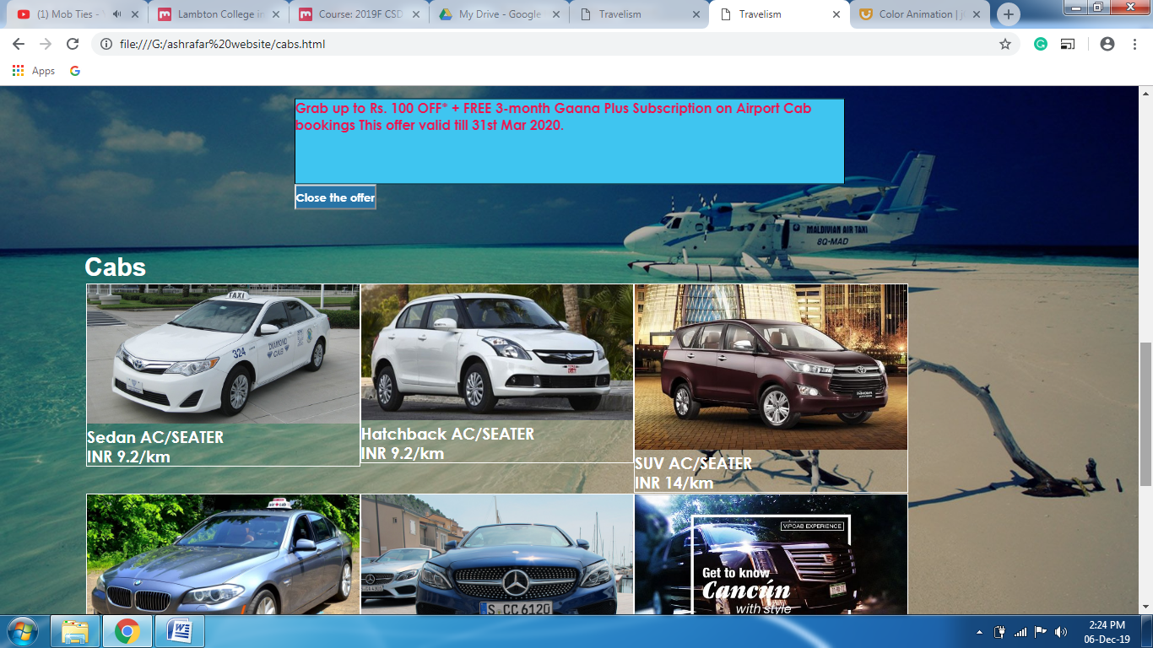

This page is used by the customer to book a cab. They can fill up the form and choose the type of car they need.Select menu widget is used in the car type.Moreover , Bxslider plugin has been used for the slideshow.